Complete Workflow: Building and Integrating a Digital Twin with Reaction Force Prediction
Open Example in MATLAB: Search for "Perform Safe Trajectory Tracking Control Using Robotics Manipulator Blocks" in MATLAB Help.
Run and Load Simulink File: Execute the script and open the corresponding Simulink model.
Add MATLAB Functions: Insert MATLAB functions into the Simulink subsystem to write signals to the workspace.
Stop MATLAB Script: Halt the script execution to make further modifications.
Add Workspace Blocks: Place blocks in Simulink to write signal data to MATLAB's workspace.
Write Data to MySQL: Use MATLAB to log workspace data into a MySQL database.
Develop Machine Learning Model: Train an ML model (e.g., XGBoost) using data fetched from MySQL.
Import ML Model into MATLAB: Load the trained model (pickle file) into MATLAB using Python integration.
Create Prediction Function: Write a MATLAB function to make predictions using the imported ML model.
Integrate Prediction into Simulink: Add a MATLAB Function Block in Simulink to use the prediction function for dynamic simulation.

Part 1: Setting Up the Simulink Model
- Open MATLAB Software:
  - Launch MATLAB and go to Home → Help.
- Search for the Example:
  - Type "Perform Safe Trajectory Tracking Control Using Robotics Manipulator Blocks".
- Open the Example:
  - Click on the example with the same name and open the Live Script.
- Load the Simulink Model:
  - Run the script to load the robotSafeTrajectoryTracking.slx Simulink model.
  - View the robot’s movement in the Simulation Explorer.
Part 2: Interacting with the Model
- Adjust Object Position:
  - Use the Object Position Slider in the Simulink model to move the object dynamically.
- Modify Trajectory Scaling:
  - Adjust the Trajectory Scaling to observe how the robot avoids collisions.
Part 3: Enhancing the Simulink Model
- Open the Subsystem:
  - Double-click the "Simscape Model with Simple Contact Mechanics" subsystem to explore the signals:
    - Input torques (torque_input1 to torque_input7).
    - End-effector position (endeffectorPos).
    - End-effector velocity (endeffectorVel).
    - Object position (objectPos) and reaction force (reaction_force).
- Add MATLAB Functions for Workspace Variables:
  - For each signal, add a MATLAB Function Block to write the signal to a workspace variable using:
  - function writeToWorkspace(singleValue)
  - assignin('base', 'torque_input1_sm', singleValue);
  - end
  - Replace torque_input1_sm with variable names for each signal.
Part 4: Connecting MATLAB with MySQL
- Install MySQL JDBC Driver:
  - Add the MySQL JDBC driver to MATLAB:
  - javaaddpath('C:\mysql-connector-j-9.0.0\mysql-connector-j-9.0.0.jar');
- Establish Database Connection:
  - Use the following code in MATLAB to connect to MySQL:
  - conn = database('', 'root', '1234', ...
  - 'Vendor', 'MySQL', ...
  - 'Server', 'localhost', ...
  - 'PortNumber', 3306, ...
  - 'JDBCDriver', 'com.mysql.cj.jdbc.Driver', ...
  - 'URL', 'jdbc:mysql://localhost:3306/matlab_db');
  - assignin('base', 'conn', conn);
- Log Signal Data to MySQL:
  - Write a loop in MATLAB to log workspace variables to the database:
  - while true
  - customTimestamp = datestr(now, 'yyyy-mm-dd HH:MM:SS');
  - query = sprintf("INSERT INTO urdf_robot (torque_input1, ..., reaction_force, timestamp) VALUES (%f, ..., %f, '%s')", ...);
  - exec(conn, query);
  - pause(1);
  - end
Part 5: Training the XGBoost Model
- Fetch Data from MySQL in Python:
  - Use the following Python code:
  - import mysql.connector
  - import pandas as pd

  - conn = mysql.connector.connect(
  - host='localhost',
  - user='root',
  - password='1234',
  - database='matlab_db'
  - )

  - query = "SELECT * FROM urdf_robot;"
  - df = pd.read_sql(query, conn)
  - conn.close()
- Train the XGBoost Model:
  - Define features (X) and target (y), then train the model:
  - from xgboost import XGBRegressor
  - from sklearn.model_selection import train_test_split
  - from sklearn.metrics import mean_squared_error
  - import pickle

  - X = df[['torque_input1', ..., 'objectPos']]
  - y = df['reaction_force']
  - X_train, X_test, y_train, y_test = train_test_split(X, y, test_size=0.2, random_state=42)

  - model = XGBRegressor(objective='reg:squarederror', n_estimators=100, learning_rate=0.1, max_depth=3)
  - model.fit(X_train, y_train)

  - with open('xgboost_reaction_force_model.pkl', 'wb') as f:
  - pickle.dump(model, f)
Part 6: Loading and Using the Model in MATLAB
- Copy the Pickle File:
  - Place xgboost_reaction_force_model.pkl in a MATLAB-accessible directory.
- Load the Model:
  - Use the load_reactionForce_model.m function:
  - function load_reactionForce_model()
  - model = py.pickle.load(py.open('xgboost_reaction_force_model.pkl', 'rb'));
  - assignin('base', 'reactionForcemodel', model);
  - end
- Predict Reaction Force:
  - Use the predict_reactionForce.m function:
  - function [reaction_force_predicted] = predict_reactionForce(new_data)
  - model = evalin('base', 'reactionForcemodel');
  - new_data_py = py.numpy.array(new_data).reshape(py.int(1), py.int(length(new_data)));
  - reaction_force_predicted = double(model.predict(new_data_py));
  - end
Part 7: Integrating Predictions into Simulink
- Add Constant Blocks:
  - Add Constant Blocks for:
    - torque_input1_sm, ..., objectPos_sm.
- Add MATLAB Function Block:
  - Add the following code to the MATLAB Function Block:
  - function reactionForce_SLX = reactionForce(torque_input1, ..., objectPos)
  - coder.extrinsic('predict_reactionForce');
  - reactionForce_SLX = 0;
  - new_data = [torque_input1, ..., objectPos];
  - reactionForce_SLX = predict_reactionForce(new_data);
  - end
- Connect Blocks:
  - Link the Constant Blocks to the MATLAB Function Block inputs.
  - Connect the output (reactionForce_SLX) to a Scope Block.
Part 8: Logging Predictions to MySQL
- Update MATLAB Function Block:
  - Add code to log predictions:
  - customTimestamp = datestr(now, 'yyyy-mm-dd HH:MM:SS');
  - query = sprintf("INSERT INTO urdf_robot_predictions (...) VALUES (%f, ..., %f, '%s')", ..., reactionForce_SLX, customTimestamp);
  - conn = evalin('base', 'conn');
  - exec(conn, query);
- Create MySQL Table for Predictions:
  - Define a new table in MySQL:
  - CREATE TABLE urdf_robot_predictions (
  - id INT AUTO_INCREMENT PRIMARY KEY,
  - torque_input1 FLOAT,
  - ...,
  - reaction_force FLOAT,
  - timestamp DATETIME
  - );
Part 9: Run the Simulation
- Prepare the System:
  - Load the XGBoost model using:
  - load_reactionForce_model();
- Simulate the Model:
  - Set the simulation time (e.g., 300 seconds) and click Run.
- Verify Predictions in MySQL:
  - Query the urdf_robot_predictions table:
  - SELECT * FROM urdf_robot_predictions ORDER BY timestamp DESC;
Expected Outcome
- Simulink dynamically predicts reaction forces using the XGBoost model.
- Predictions and input variables are logged into the MySQL database for analysis.

Pictorial step-by-step procedures:
Pre-requisites:
Step1: Setup Jupyter Notebook and MATLAB with the required Python
  - Open MATLAB and perform the following in the Command Window as shown in Figure 1 MATLAB Command Prompt Getting Started :
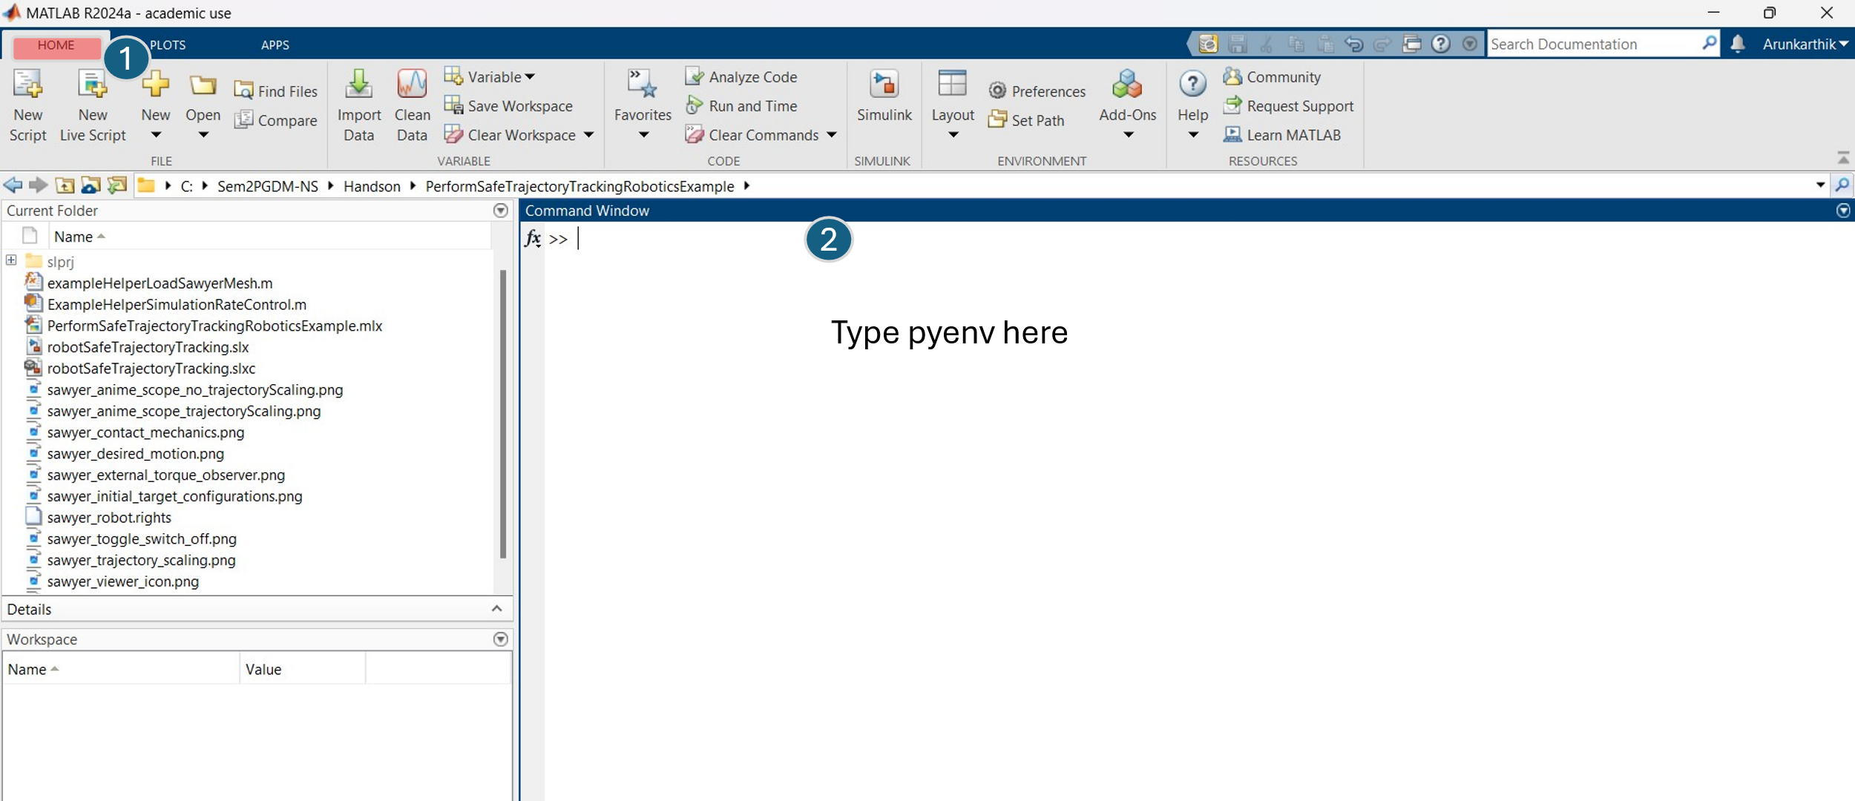
Figure 1 MATLAB Command Prompt Getting Started

You can see the Python Executable path as shown in Figure 2 Python Executable Path in your Laptop / PC
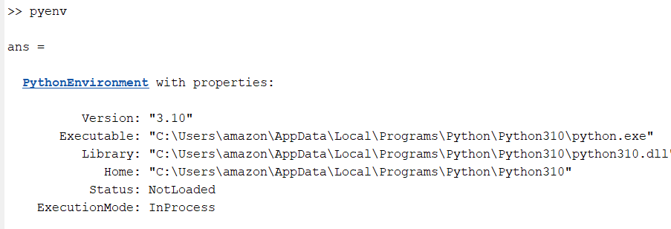
Figure 2 Python Executable Path in your Laptop / PC
If there is no path mentioned in Executable, no compatible Python version installed in your laptop. download Python 310 and install on your laptop. Install Jupyter Notebook also. After the same installation, check the Executable python path in MATLAB.
  - Install Python Libraries in your MATLAB Python Environment.
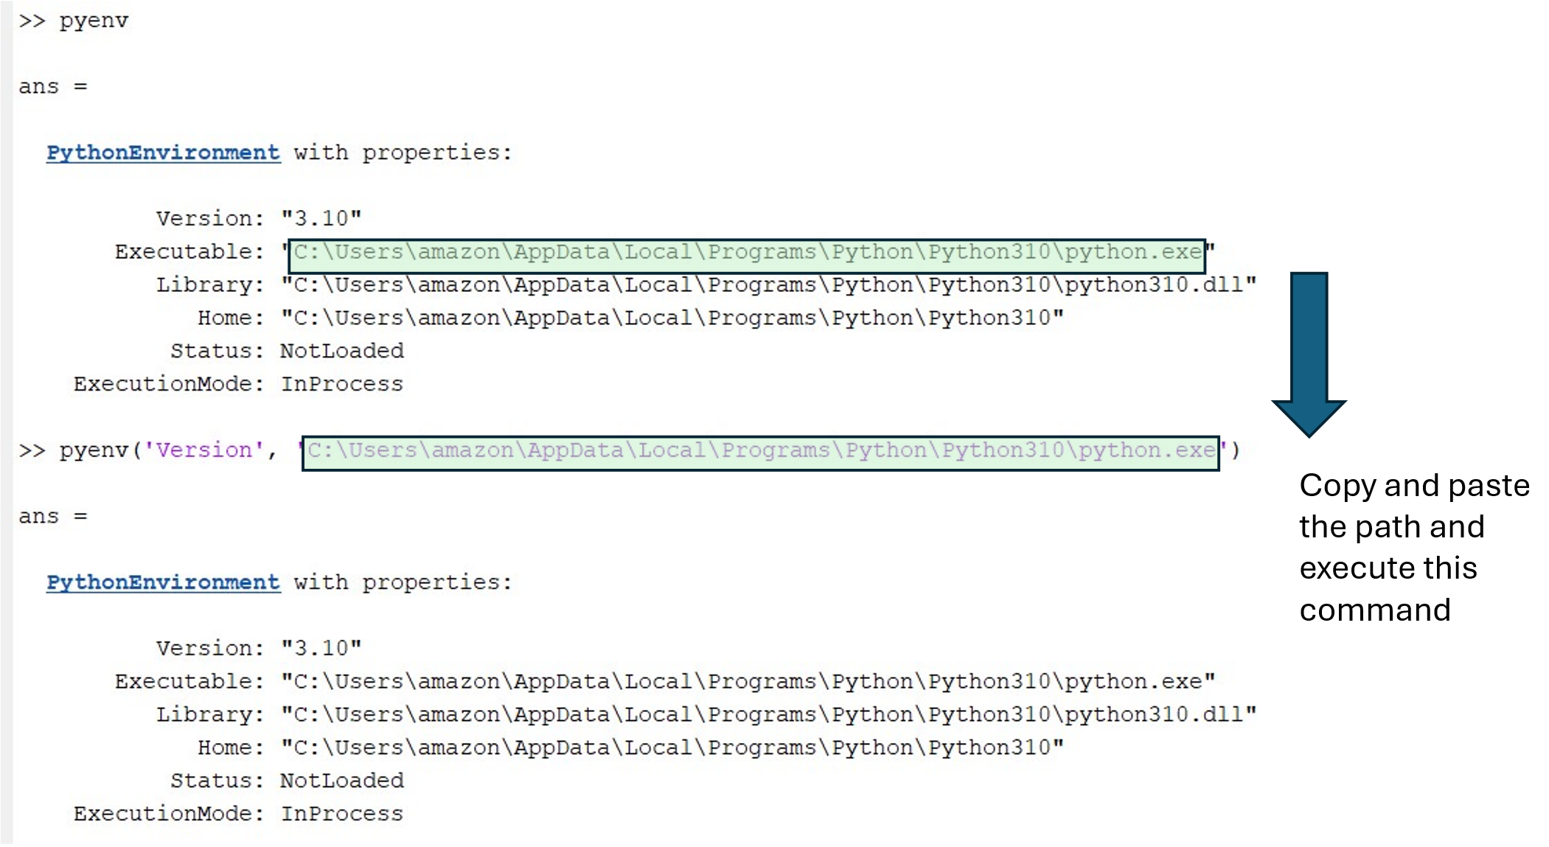

  - Now, you can install Python libraries, as shown below.
In the MATLAB Comman Window execute the following commands one by one.
system('pip install xgboost')
system('pip install scikit-learn')
system('pip install pandas')
If you have any more dependencies you will use for the ML modelling, install them as well. Later, we will be importing our ML model from Python as a pickle file and the exact needs Python dependencies (libraries).

Step2: Install MATLAB addons:
Make sure you installed the following addons on your MATLAB.
MATLAB
Simulink
Communications Toolbox
Computer Vision Toolbox
Control System Toolbox
Curve Fitting Toolbox
Data Acquisition Toolbox
Deep Learning Toolbox
Embedded Coder
Industrial Communication Toolbox
MATLAB Coder
MATLAB Compiler SDK
MATLAB Compiler
MATLAB Report Generator
Model-Based Calibration Toolbox
Motor Control Blockset
Optimization Toolbox
Partial Differential Equation Toolbox
Robotics System Toolbox
Simscape Driveline
Simscape Electrical
Simscape Fluids
Simscape Multibody
Simscape
Simulink 3D Animation
Simulink Check
Simulink Code Inspector
Simulink Coder
Simulink Compiler
Simulink Control Design
Simulink Coverage
Simulink Design Optimization
Simulink Design Verifier
Simulink Desktop Real-Time
Simulink PLC Coder
Simulink Real-Time
Simulink Report Generator
Simulink Test
Stateflow

If any of the addons missed to be installed, go to Addons and get addons as shown in Figure 3 Get addons MATLAB
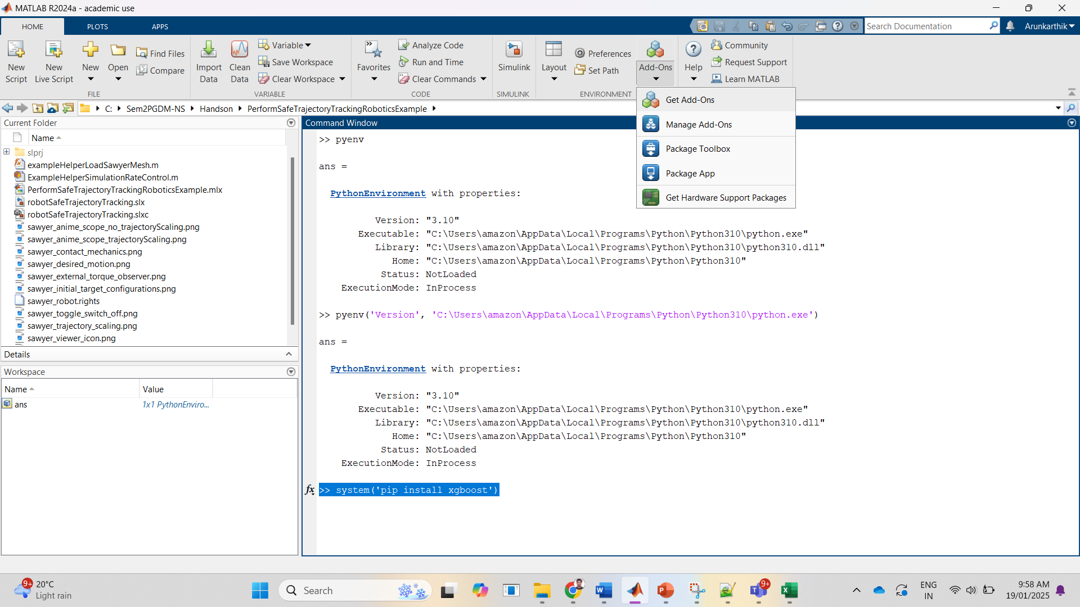
Figure 3 Get addons MATLAB
A separate window will appear as shown in the Figure 4 Install Addons by searching in the Get Addon window
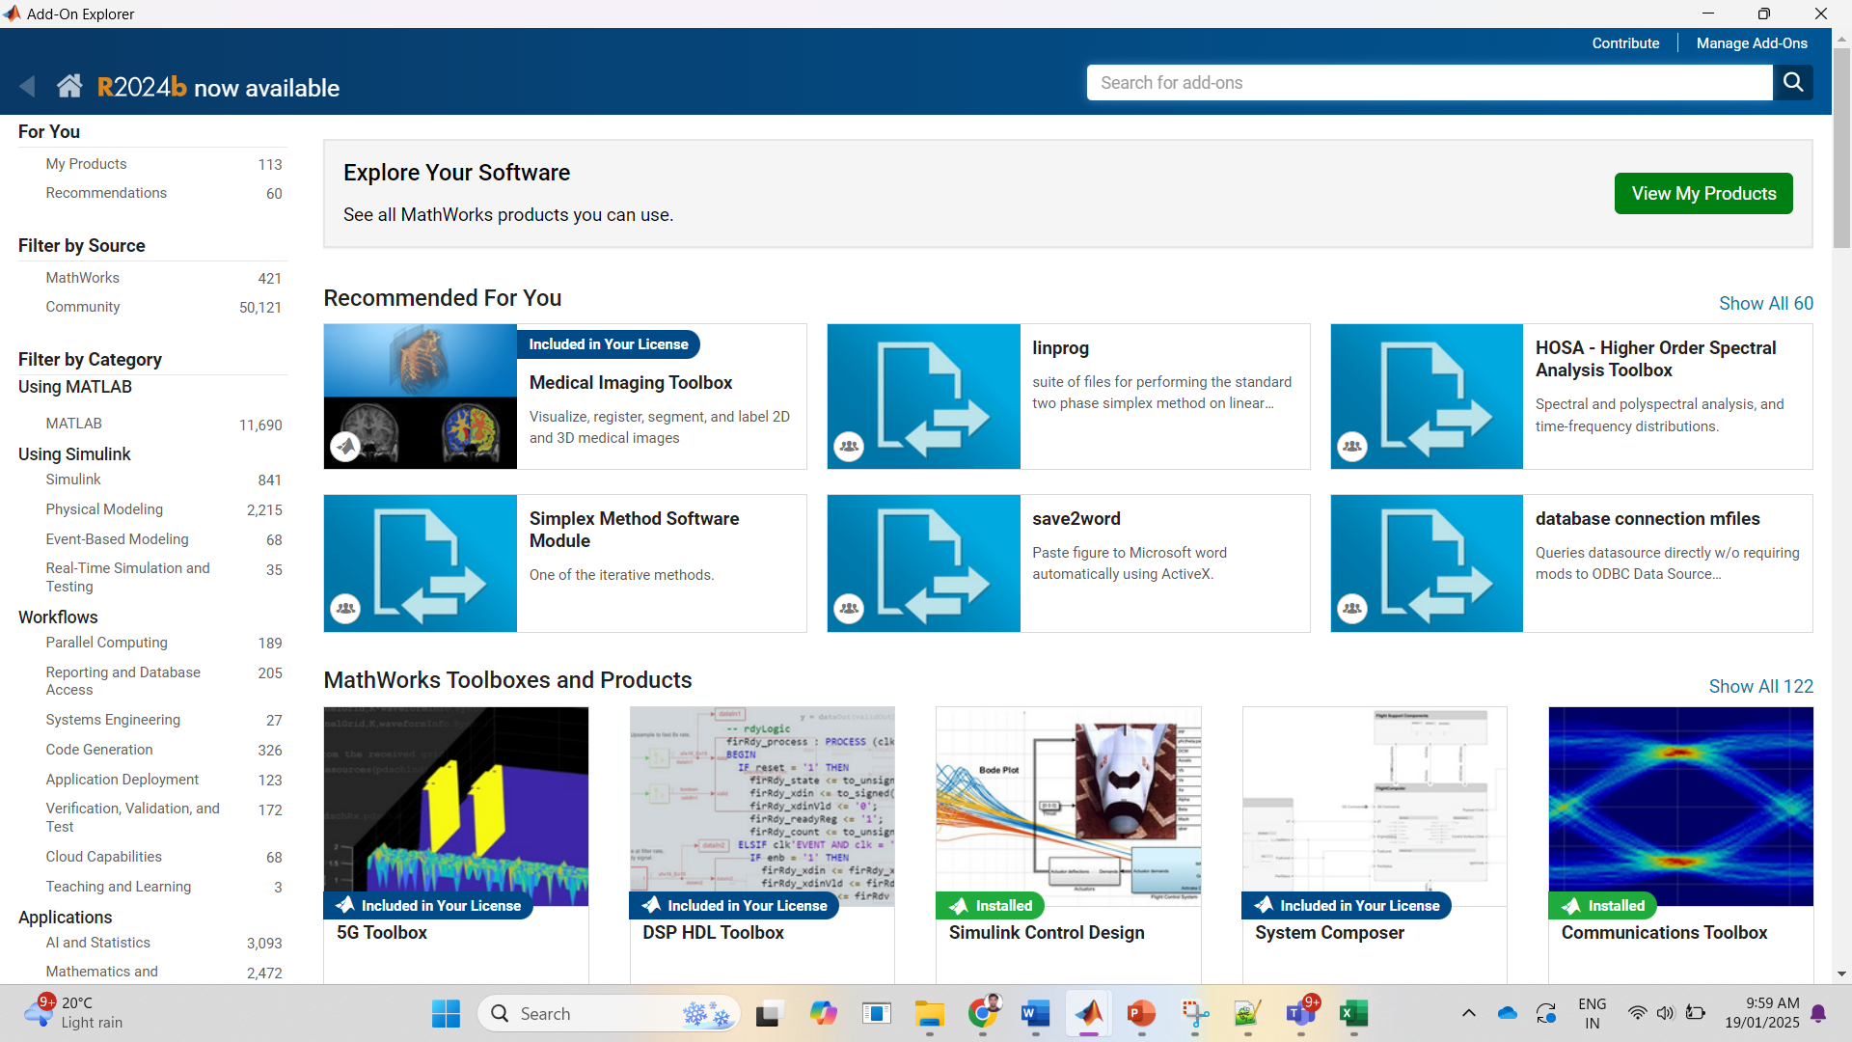
Figure 4 Install Addons by searching in the Get Addon window
Search for the tool box you need there in the sear for add ons and install the same.
Make sure you saved all the MATLAB files and Simulink files you are using currently while installing Addons, the same might get impacted.

